IMPLEMENTING CRM FOR RESULT TRACKING OF A CANDIDATE WITH INTERNAL MARKS

**1. Introduction:**

# OVERVIEW:

The improved features of **CRM** software have increased both its complexity and necessity. Nearly half of **CRM i**mplementation campaigns suffer from improper preparation and misaligned objectives among internal stakeholders. A properly conceived **CRM** implementation strategy covers the breakdown of its goals, research, strategy, development and future. This article is for small business owners who want to make sure they are taking the right steps when implementing a new **CRM** system.

# PURPOSEL:

It is saves a lot of time. The purpose of the project is to manage the school student’s result tracking process in the easy way. Students do not need to check the notice board and everyone will stay updated this is the main purpose of this project .Can work easily. Increase candidate quality.

# 2. Problem Definition & Design Thinking

# 2.1. Empathy Map

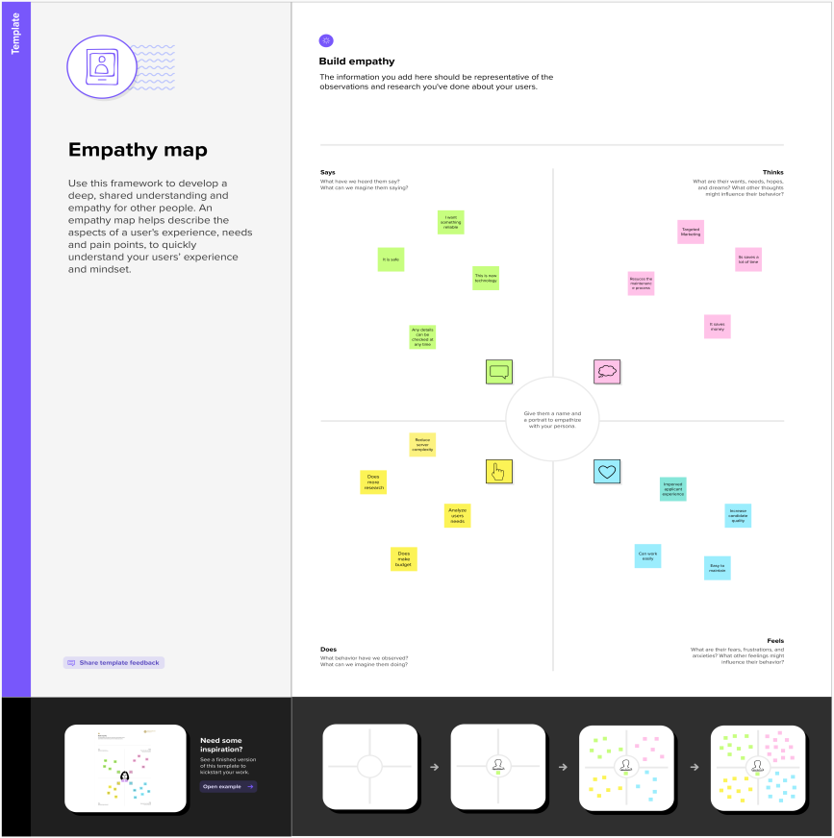

# 2.2. Ideation & Brainstorming Map

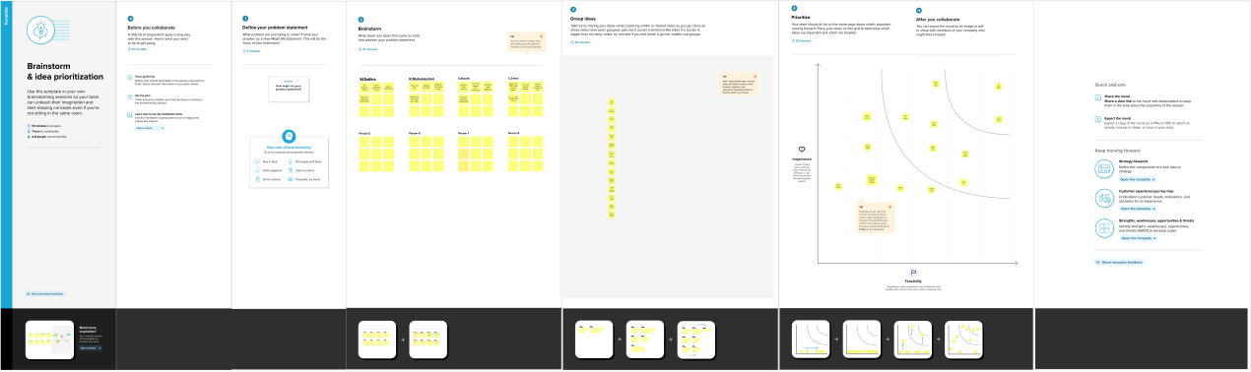

|  |  |
| --- | --- |
| Object Name | Fields in the object |
| SEMESTER | |  |  | | --- | --- | | **Field label** | **Data Type** | | **Semester Name** | **Text** | | **Course (lookup)** | **Text** | |
| COURSE DETAILS | |  |  | | --- | --- | | **Field label** | **Data type** | | **Course Name** | **Text** | | **Course ID** | **Text** | |
| INTERNAL RESULTS | |  |  | | --- | --- | | **Field label** | **Data type** | | **Candidate ID** | **Text** | | **Course ID** | **Text** | | **Marks** | **Text** | |

**3. RESULT:**

# 3.1 Data Model:

# 

# 3.2. Activity & Screenshot

# Creating Developer Account:

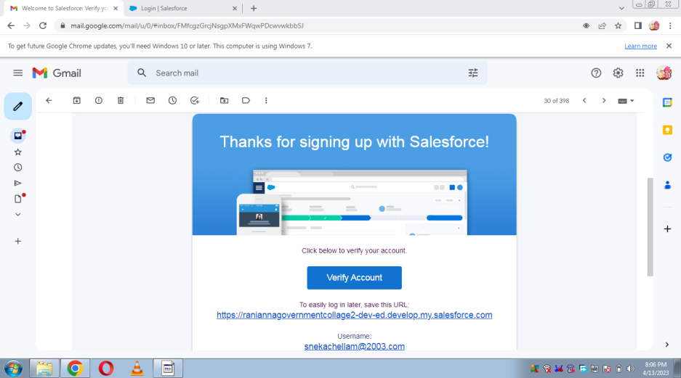

Using this [**https://developer.salesforce.com/**](https://developer.salesforce.com/) link we signup the sales force platform and finally we get the verification mail that shown in the above figure.

# Sales force Login:

# C:\Users\Public\Pictures\Pictures\salesforce.PNG

We used [**https://login.salesforce.com/**](https://login.salesforce.com/)this link to login the sales force platform. This link asked our username and password only.

# Object:

# C:\Users\AKASIYAN\AppData\Local\Microsoft\Windows\Temporary Internet Files\Content.Word\1681437725056.jpg

For this school Students internal result project we created 5 objects. They are Semester, Candidate, Course details, Lecturer details and Internal Results.

# Fields and Relationship:

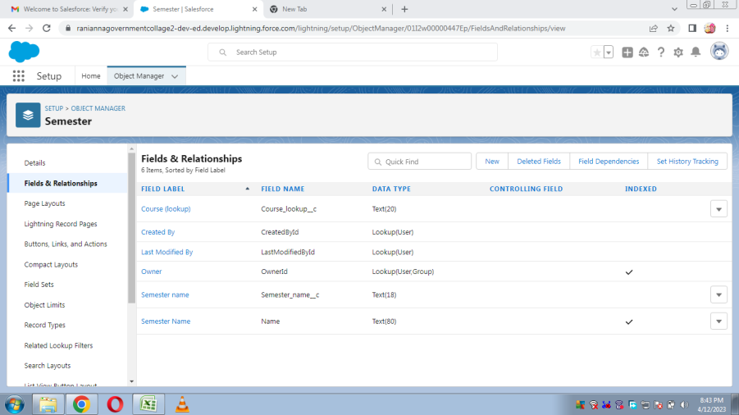

Relationships are created by creating custom relationship fields on an object. This is done so that when users view records, they can also see and access related data.

# Lightning App:

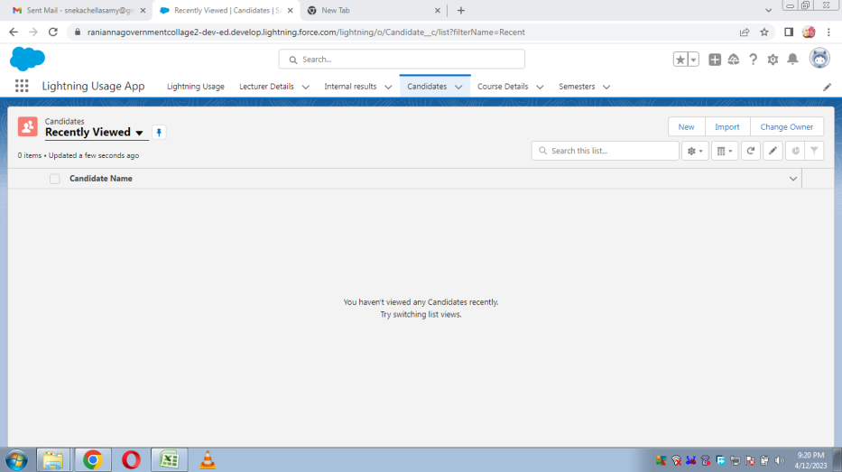

Relationships are created by creating custom relationship fields on an object. This is done so that when users view records, they can also see and access related data.

# Users:

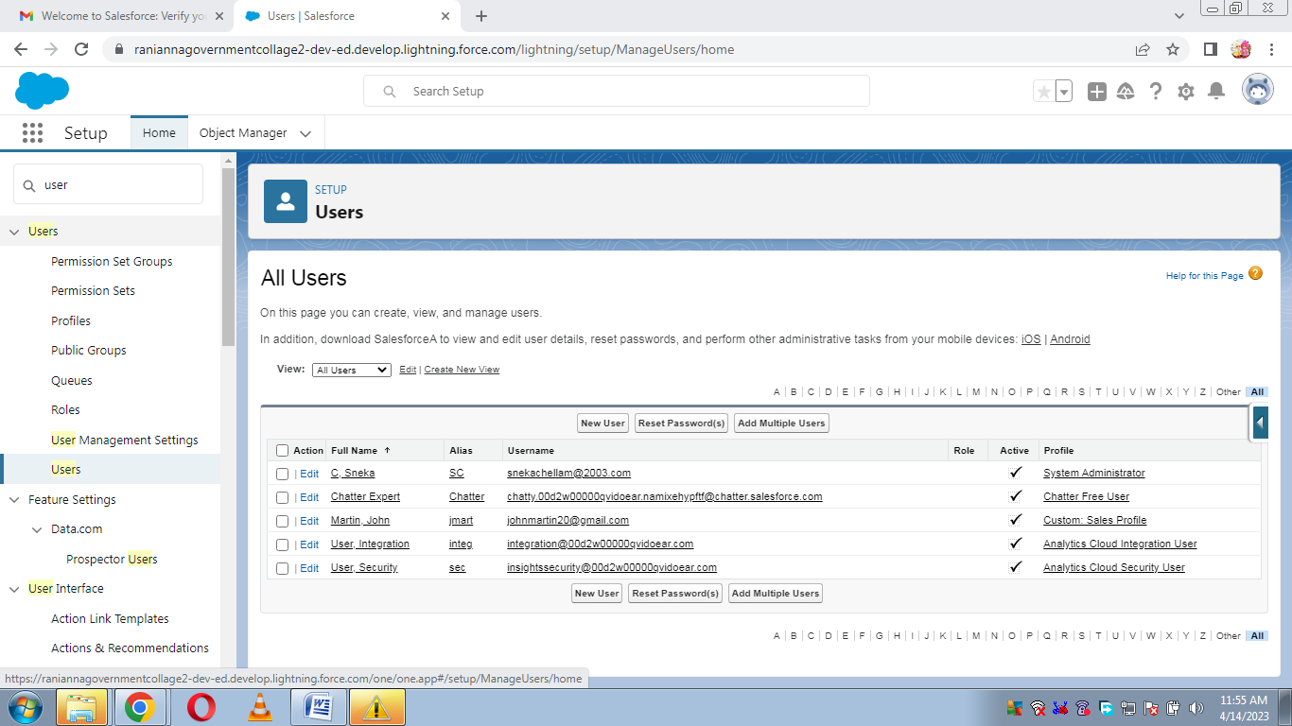

We created the Users in John Martin.

# Reports:

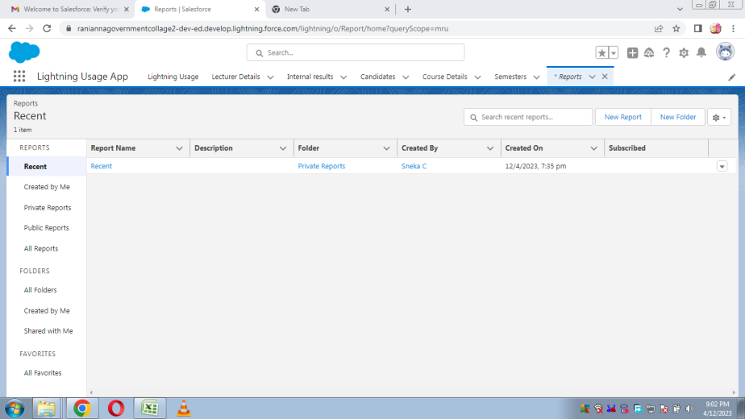

From the report tab we create report type as students with school and parent report. They are checked by click the run button.

# Dash Boards:

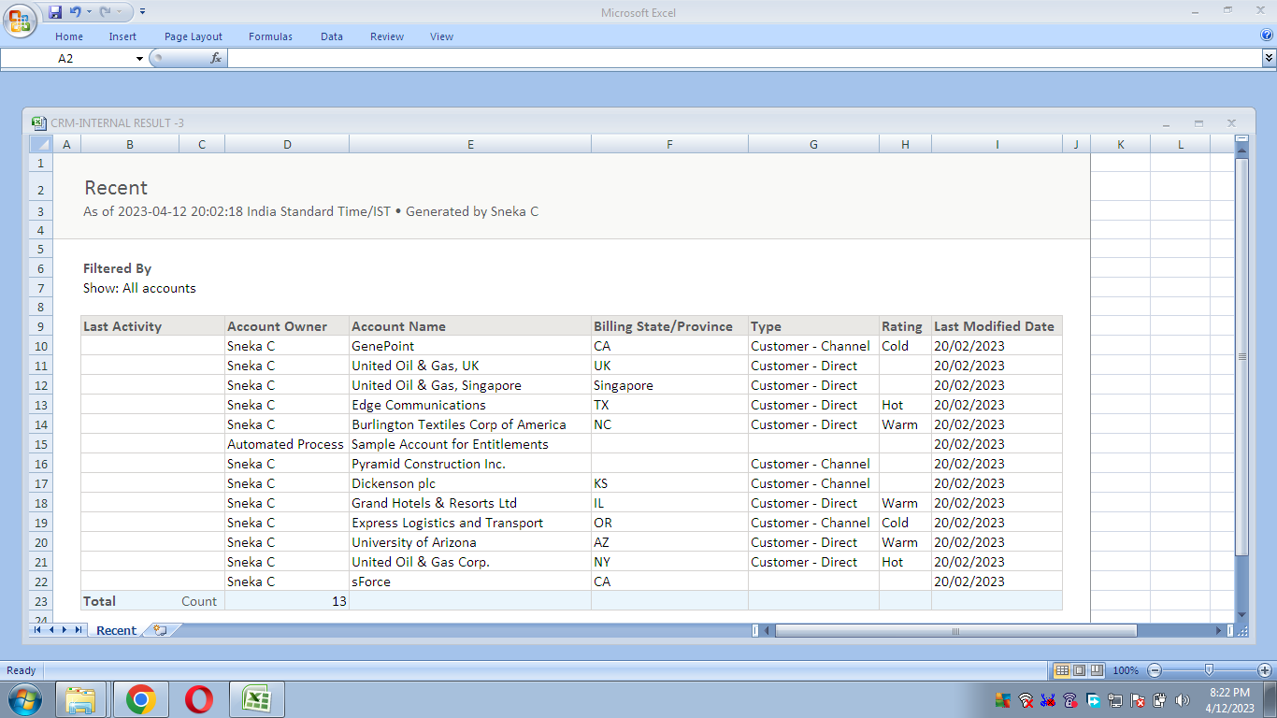

**4. Trailhead Profile Public URL**

Team Lead – https://trailblazer.me/id/susim6

Team Member 1 –https://trailblazer.me/id/rmahalakshmi

Team Member 2 – https://trailblazer.me/id/mmalathi12

Team Member 3 – https://trailblazer.me/id/snekc2

**5. Advantages & Disadvantage**

# Advantages

* It allows for the consolidation of customer data and the basis for deep insights.
* It speeds up the sales conversion process.
* It increases staff productivity, lowering time-cost.
* It allows geographically dispersed teams to collaborate effectively.
* Improves customer experience by allowing personalization and improved query resolution.

# Disadvantage

* Customer experience may worsen due to staff over-reliance on the system.
* Security and data protection issues with centralized data.
* The excess initial time and productivity cost at the implementation.
* Requires a process-driven sales organization.
* CRM may not suit all businesses.

6. Applications

* I want something reliable
* Target marketing
* Increase candidate quality
* Can work easily
* Streamlining internal sales processes

7. Conclusion

Student Internal Mark Management System deals with student details, academic related reports, college details and course details. It tracks all the details of a student from the day one to the end of his course which can be used for all reporting purpose, tracking of progress in the course, completed semester, upcoming semester details, exam details, project or any other assignment details, and final exam result.

8. Future scope

Scope of education means range of view, outlook, field or opportunity of activity, operation and application of education. Education has a wider meaning and application.